**09.08 Lottery**

**Difficulty: hard  
Size: L**

After the successful cottage retreat people decided to make a draw (raffle/lottery, arpajaiset) for deciding who gets the remaining food. Make a program that asks for the name of all the attendants and randomize the winner.

Sample output after two names have been added:

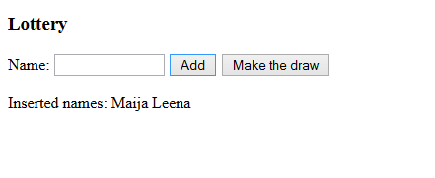

Sample output after several names have been added AND the draw has been made:

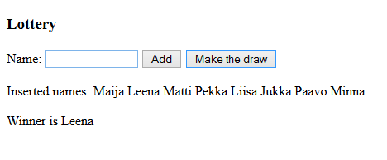

**TEMPLATES:**

Use[HTML Code](https://vw4.viope.com/content/9b67da7ed75bf67ca4b0d6d7632af92297383fc6/09.08LotteryEx.html) here and add functions to .js file  ([JavaScript Template Code](https://vw4.viope.com/content/9b67da7ed75bf67ca4b0d6d7632af92297383fc6/09.08LotteryEx.js))

**NOTE!**

There is a random() function call in code. Please run the correct code many times in Viope.

**HINTS:**

1. Asks for the name of all the attendants
   * Define the array variable and create the array object inside the script element, but NOT inside the function. Then it will be global and thus available for all functions to read from or write to.

var names = []; // defining a variable and creating empty array object

* + When the Add button is pressed assign the name from the input field to the array by using push method ([w3shool Array Methods](http://www.w3schools.com/js/js_array_methods.asp))

names.push(name)

* + Empty the input field as that name was just put in the array

document.getElementById("name").value = "";

* + Additionally show the inserted names so far under the input field:
    - Go through the array in a for loop adding each name at the end of the namesText.
    - Set that text to HTML document

1. Randomize the winner
   * When "Make the draw" button is pressedRandomize the index of the winner:

var winningIndex = Math.floor(Math.random() * names.length);

names.length==6

names[0] ....names[5]

*Example output:*

Inserted names: Maija

Inserted names: Maija Leena

Inserted names: Maija Leena Matti

<br>Winner is Maija

*The verification of program output does not account for whitespace and is not case-sensitive (the least strict comparison level)*